17.0 Introduction
In order to provide the functionality required for this lab, the companion VM may require a minute or two to load.
The boot process starts with the bootloader, the program that loads the kernel into memory and executes instructions to boot the system. Typically, administrators do not find it necessary to make many changes to the bootloader, but you should know how to modify some of the key GRUB configurations, as well as know how to interact with the bootloader interactively when the system is booting.
- Previous
- Next

17.1 Step 1
Please use the Ubuntu image to complete the following steps. Select the Ubuntu PC by clicking on the Ubuntu PC tab in the window on the right side of the screen.
Log in to the system using the root account. When prompted, provide the root password:
root
netlab123
Ubuntu 18.04.2 LTS ubuntu tty1
ubuntu login: root
Password:
Welcome to Ubuntu 18.04.2 LTS (GNU/Linux 4.15.0-45-generic x86_64)
* Documentation: https://help.ubuntu.com
* Management: https://landscape.canonical.com
* Support: https://ubuntu.com/advantage

The programs included with the Ubuntu system are free software;
the exact distribution terms for each program are described in the
individual files in /usr/share/doc/*/copyright.

Ubuntu comes with ABSOLUTELY NO WARRANTY, to the extent permitted by
applicable law.

root@ubuntu:~#
- Previous
- Next

17.2 Step 2
This system supports GRUB2. View the first 10 lines of the /boot/grub/grub.cfg file by executing the following command:
head /boot/grub/grub.cfg
root@ubuntu:~# head /boot/grub/grub.cfg
#
# DO NOT EDIT THIS FILE
#
# It is automatically generated by grub-mkconfig using templates
# from /etc/grub.d and settings from /etc/default/grub
#
### BEGIN /etc/grub/d/00_header ###
if [ -s $prefix/grubenv ]; then
set have_grubenv=true
- Previous
- Next

17.3 Step 3
Notice that this file is not designed to be edited directly. Instead, you modify settings in the /etc/default/grub file. To edit this file, first launch the vi editor:
vi /etc/default/grub
root@ubuntu:~# vi /etc/default/grub
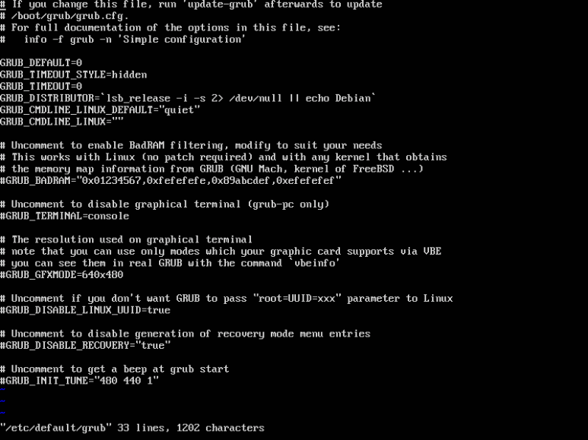
- Previous
- Next

17.4 Step 4
Next, we will change the value of GRUB_TIMEOUT_STYLE to menu and GRUB_TIMEOUT to 30. Execute the following vi commands ([ESC] means press the Escape key and the 0 character is zero):

7G
$
xxxxxx
a
menu
[ESC]
[Down Arrow Key]
x
a
30
[ESC]
:wq
[Enter]
- Previous
- Next

17.5 Step 5
Next, execute the following command to verify your changes. They should look like the following graphic:
root@ubuntu:~# head /etc/default/grub
# If you change this file, run 'update-grub' afterwards to update
# /boot/grub/grub.cfg.
# For full documentation of the options in this file, see:
# info -f grub -n 'Simple configuration'

GRUB_DEFAULT=0
GRUB_TIMEOUT_STYLE=menu
GRUB_TIMEOUT=30
GRUB_DISTRIBUTOR='lsb_release -i -s 2> /dev/null || echo Debian'
GRUB_CMDLINE_LINUX_DEFAULT=“quiet”
- Previous
- Next

17.6 Step 6
Notice that the first line of the /etc/default/grub file indicates that the update-grub command must be executed after modifying this file. Execute that command, then reboot the system and watch the screen for the countdown:up
update-grub
root@ubuntu:~# update-grub
Sourcing file ‘/etc/default/grub’
Generating grub configuration file ...
Found linux image: /boot/vmlinuz-4.15.0-45-generic
Found initrd image: /boot/initrd.img-4.15.0-45-generic
done
root@ubuntu:~# reboot
- Previous
- Next

17.7 Step 7
When the system boots, you should see a countdown at the bottom of the screen. Before it reaches 0, press the Escape key:

[ESC]
- Previous
- Next

17.8 Step 8
After pressing the Escape key, you will be presented with the following menu:
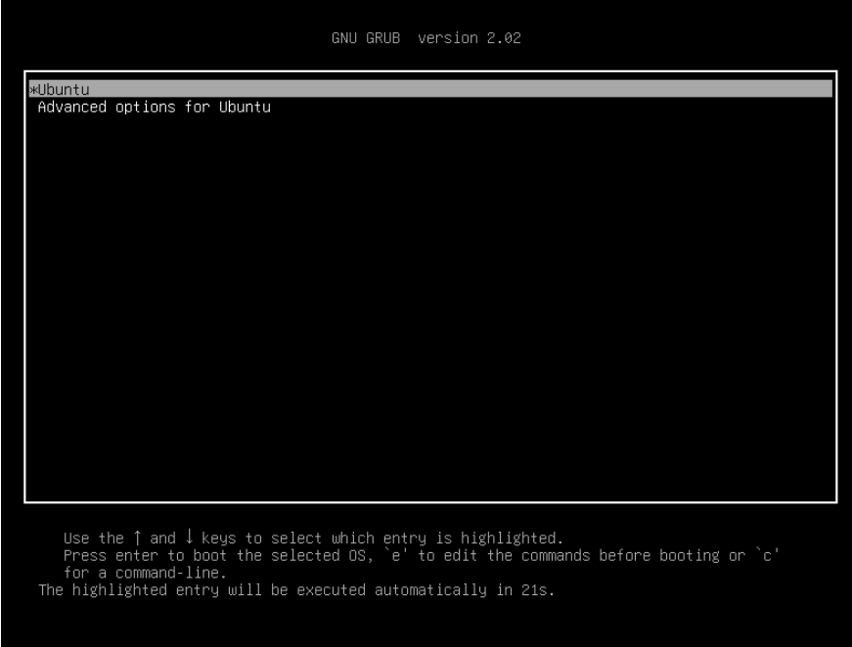
- Previous
- Next

17.9 Step 9
Press the Down Arrow key once and then press the Enter key to select Advanced options for Ubuntu. This will display another menu, which includes the ability to boot to a recovery mode:
Press Down Arrow
[Enter]
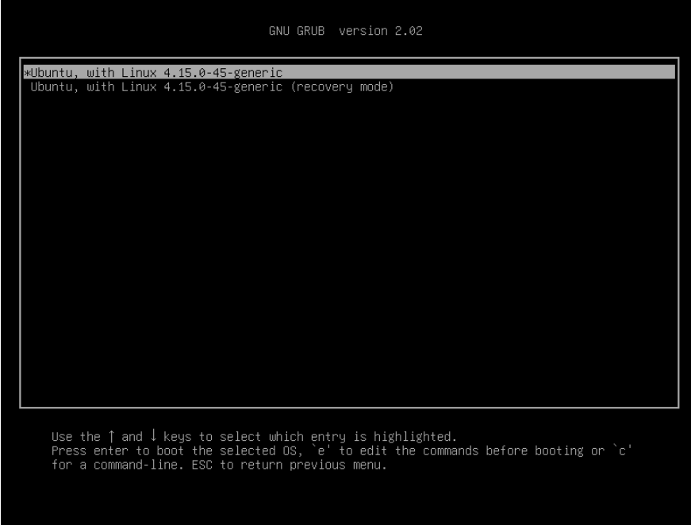
- Previous
- Next

17.10 Step 10
Press the Down Arrow key once so the "...(recovery mode)" option is selected and press the e key to enter the edit mode:
Press Down Arrow
e
- Previous
- Next

17.11 Step 11
This option will boot the system to a recovery runlevel where an administrator can fix system problems:
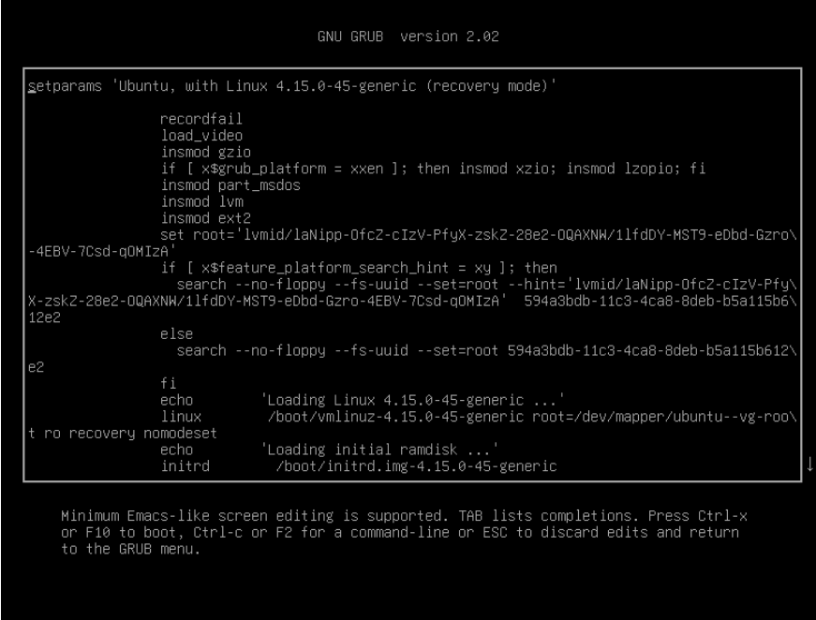
- Previous
- Next

17.12 Step 12
Press the Escape key twice to return to the primary menu:
[ESC]
[ESC]
- Previous
- Next

17.13 Step 13
Press the Enter key to boot the system:
[Enter]
- Previous
- Next

17.14 Step 14
Please use the CentOS image to complete the remaining steps. Select the CentOS PC by clicking on the CentOS Legacy PC tab in the window on the right side of the screen.
Note
This lab requires an older version of CentOS in order to practice using Grub Legacy, which is unavailable on modern systems.
Log in to the system using the root account. When prcatompted, provide the root password:
root
netlab123
CentOS release 6.10 (Final)
Kernel 2.6.32-754.el6.x86_64 on an x86_64

centos login: root
Password:
Last login: Wed Aug 20 08:17:32 on tty1
[root@centos ~]#
- Previous
- Next

17.15 Step 15
This system supports traditional GRUB. View the /boot/grub/grub.conf file by executing the following command:
cat /boot/grub/grub.conf
[root@centos ~]# cat /boot/grub/grub.conf
The timeout value determines how long the user has before the system starts booting to the default OS. In this example, there is only one OS, defined by the title dirrective. The hiddenmenu directive indicates that the GRUB menu is not displayed by default during the countdown provided by the GRUB before booting the system.
- Previous
- Next

17.16 Step 16
Modify the /boot/grub/grub.conf file by executing the following command:x
vi /boot/grub/grub.conf
[root@centos ~]# vi /boot/grub/grub.conf
- Previous
- Next

17.17 Step 17
Next, change the timeout to 60 and "comment out" the hiddenmenu directive by executing the following vi commands ([ESC] means press the Escape key):s
11G
$
x
a
60
[ESC]
Enter
Press Down Arrow
I
#
[ESC]
:wq
- Previous
- Next

17.18 Step 18
Verify your changes by viewing the /boot/grub/grub.conf file by executing the following command:
cat /boot/grub/grub.cfg
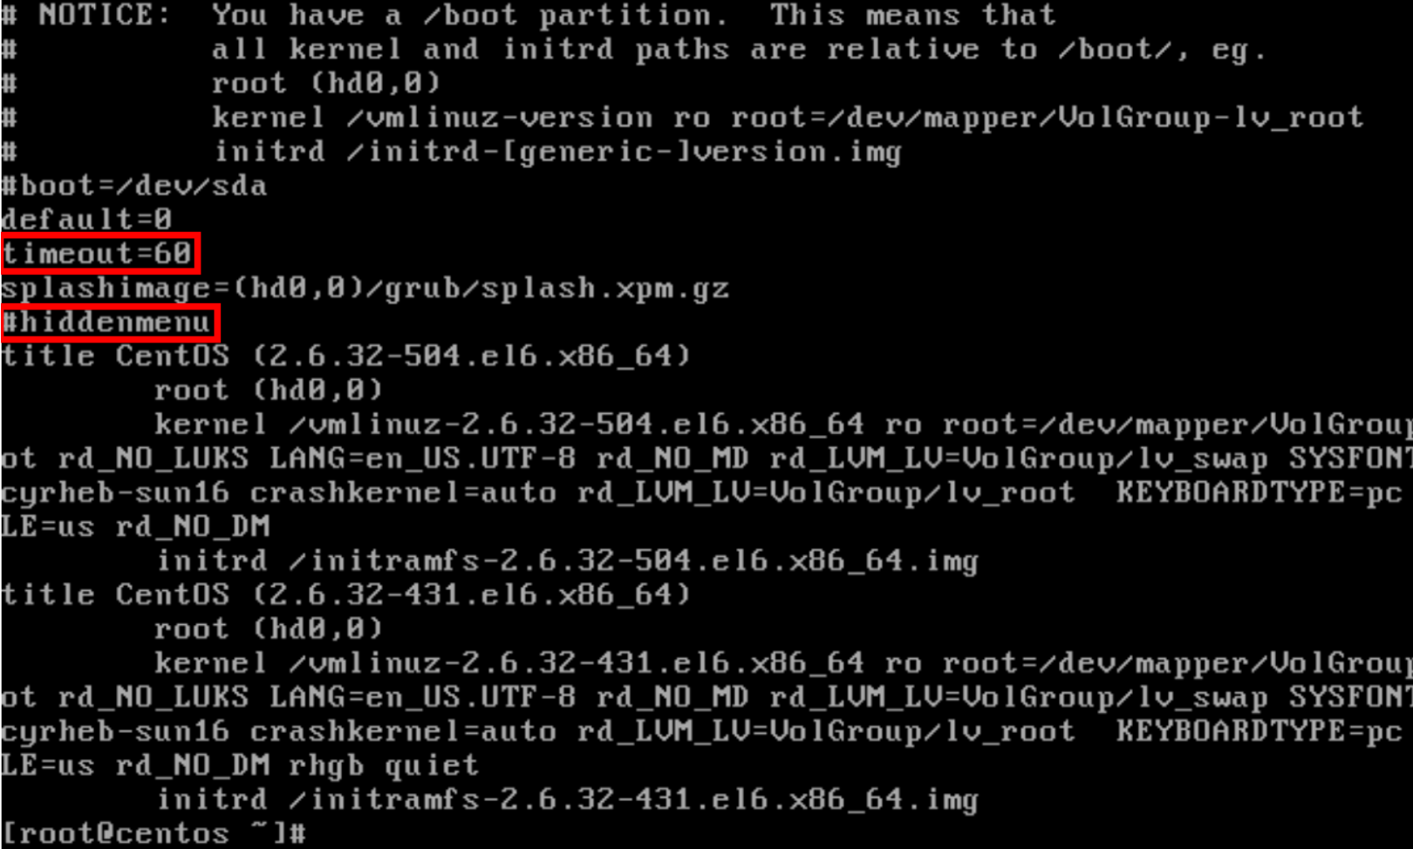
In traditional GRUB, changes to the configuration file do not require running any commands after editing the file.
- Previous
- Next

17.19 Step 19
Reboot the system and watch the screen during the boot process for the countdown to begin:
[root@centos ~]# reboot
- Previous
- Next

17.20 Step 20
When the system boots, you should see the GRUB menu countdown at the bottom of the screen. Before it reaches 0, press the Escape key:
[ESC]
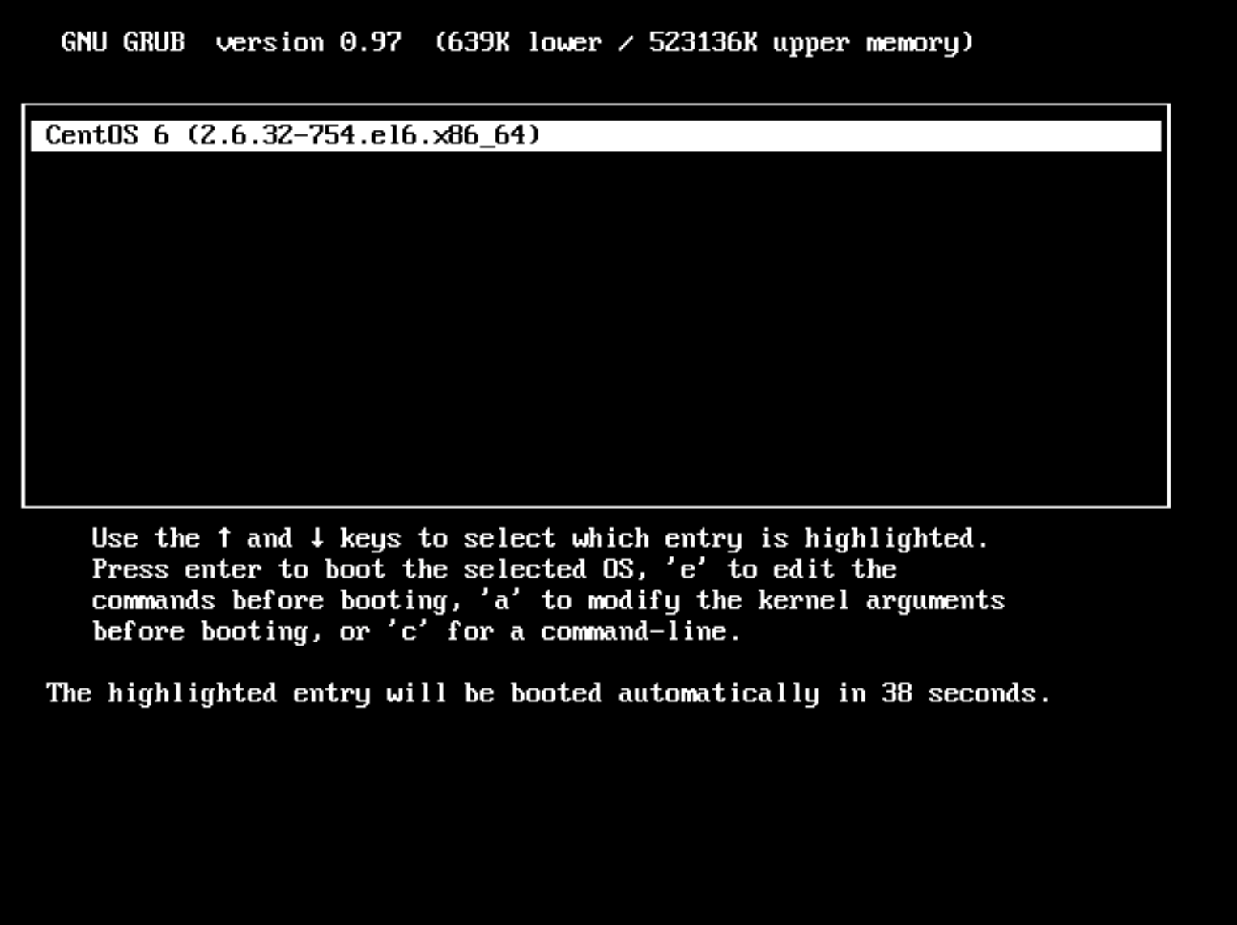
- Previous
- Next

17.21 Step 21
After pressing the Escape key, you will be presented with the following menu:
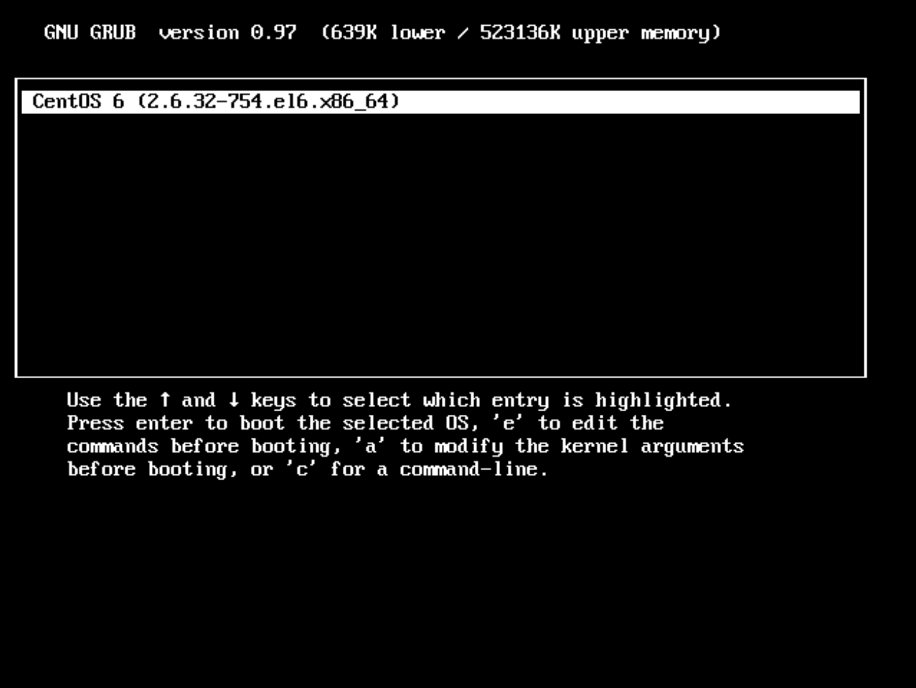
- Previous
- Next

17.22 Step 22
Type the letter e to edit the current title:
e
You will be provided with the following screen:
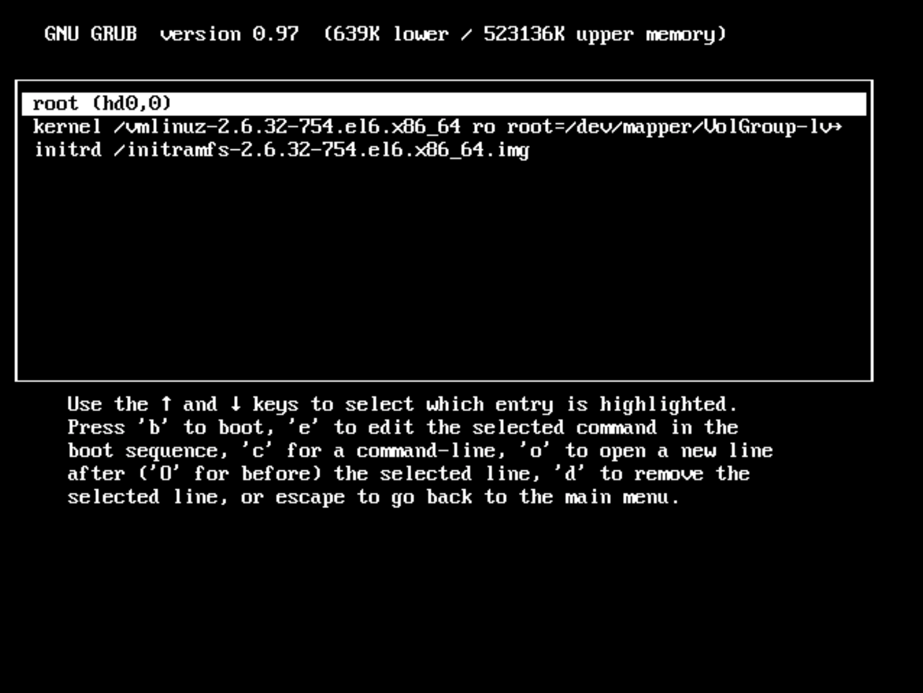
The line that you would most likely edit is the kernel line. By adding (or removing) arguments on this line, you can affect how the system will boot. Keep in mind that any changes made here are not permanent. To make them permanent, you must edit the /boot/grub/grub.conf file after booting the system.
- Previous
- Next

17.23 Step 23
Press the Down Arrow key once and then press the letter e to edit the kernel line:
Press Down Arrow
e
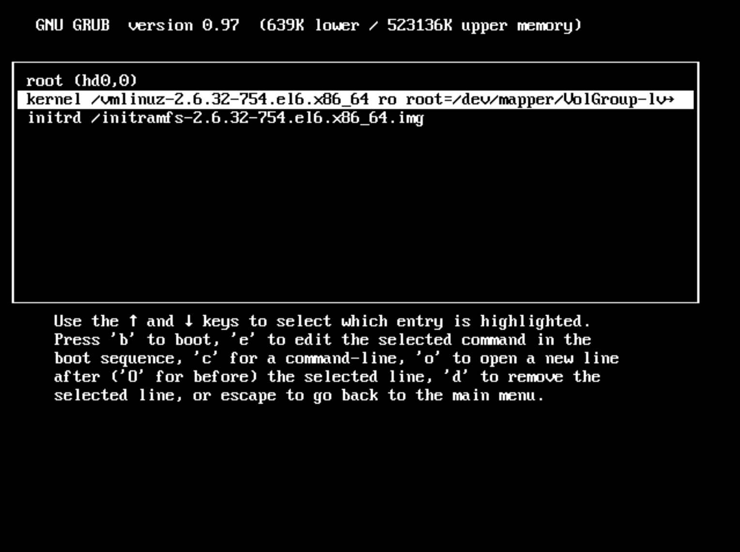
- Previous
- Next

17.24 Step 24
You will be placed in edit mode at the end of the kernel line:
[ Minimal BASH-like line editing is supported. For the first word, TAB
lists possible command completions. Anywhere else TAB lists the possible
completions of a device/filename. ESC at any time cancels. ENTER
at any time accepts your changes.]

<=VolGroup/lv_root KEYBOARDTYPE=pc KEYTABLE=us rd_NO_DM rhgb quiet_
The rhgb argument stands for Red Hat Graphical Boot. Instead of displaying text messages during boot, a graphical progress bar is displayed. While more user-friendly, this doesn't help the administrator troubleshoot boot problems.
The quiet argument suppresses many of the text messages that are displayed if the rhgb argument isn't used. Again, this may be more user-friendly, but an administrator should remove this setting when troubleshooting boot problems.
- Previous
- Next

17.25 Step 25
Press the Backspace key 10 times to remove the rhgb and quiet settings. Then, type single:
Press Backspace Key 10x
single
By adding single to the end of the kernel line, the system will be booted to the single user runlevel.
- Previous
- Next

17.26 Step 26
Your screen should look like the following:
[ Minimal BASH-like line editing is supported. For the first word, TAB
lists possible command completions. Anywhere else TAB lists the possible
completions of a device/filename. ESC at any time cancels. ENTER
at any time accepts your changes.]

<=VolGroup/lv_root KEYBOARDTYPE=pc KEYTABLE=us rd_NO_DM single
- Previous
- Next

17.27 Step 27
Press the Enter key to accept the changes:
Enter
- Previous
- Next

17.28 Step 28
You will be presented the edit screen again:
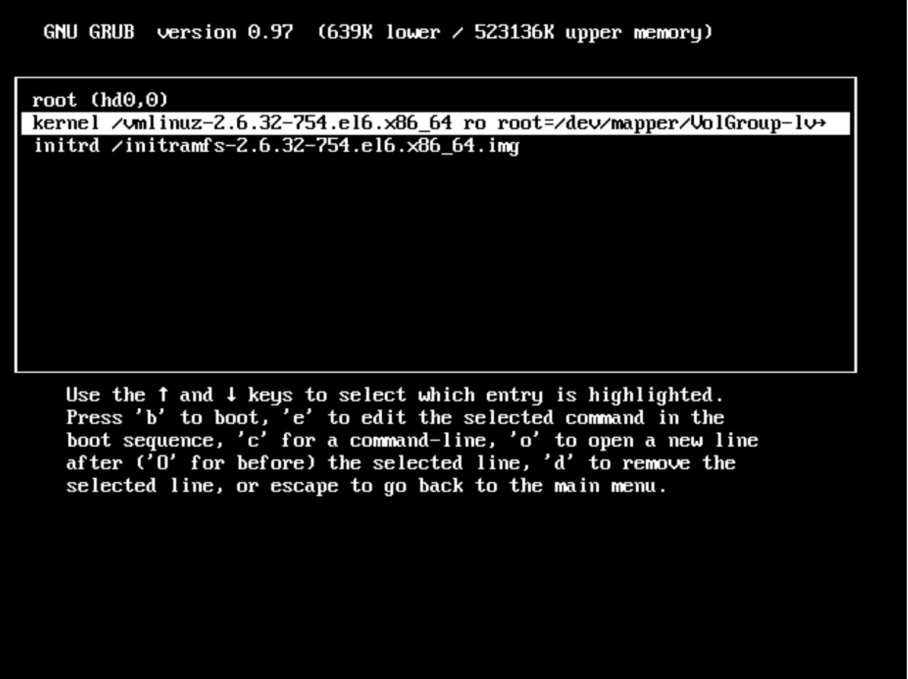
- Previous
- Next

17.29 Step 29
Press the b key to boot the system. Notice how the boot messages are displayed (your system may appear different from what you see in the following graphic).
b
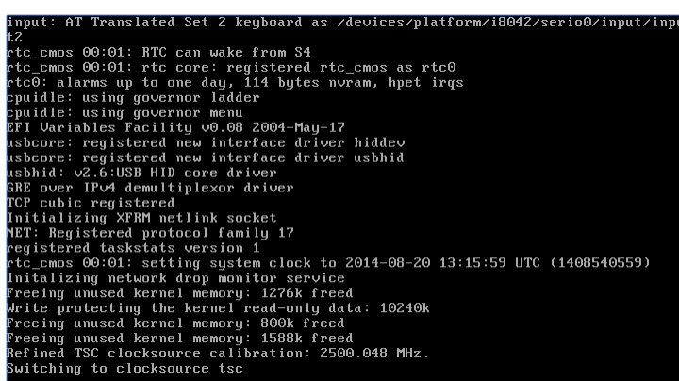
- Previous
- Next

17.30 Step 30
Notice that when the system finishes booting, you are automatically logged in as the root user:
Checking filesystems
/dev/mapper/VolGroup-lv_root: clean, 22697/262144 files, 241986/1048576 blocks
/dev/sda1: clean, 38/32768 files, 12691/131072 blocks
[ OK ]
Remounting root filesystem in read-write mode: [ OK ]
Mounting local filesystems: [ OK ]
Enabling /etc/fstab swaps: [ OK ]
[root@centos /]#
- Previous
- Next

17.31 Step 31
Type the runlevel command to verify that you are at runlevel S (or single user):
[root@centos /]# runlevel
N S
At the single user runlevel, very few processes are running, and only the administrator can access the system. The purpose of this runlevel is to troubleshoot critical system problems.
- Previous
- Next

17.32 Step 32
Let’s pretend you have fixed whatever problem prompted you to go to the single user runlevel. To boot the system to the default runlevel, Press Ctrl+D (hold down the Control key and press the letter d):
Ctrl+d
The system will boot and you will be prompted with a login screen:
CentOS release 6.10 (Final)
Kernel 2.6.32-754.el6.x86_64 on an x86_64

centos login:
- Previous
- Next

